Assignment No 2



Spring 2025

**CSE-408 Digital Image Processing**

Submitted by: MUHAMMAD SADEEQ

Registration No.: 21PWCSE2028

Section: C

“On my honor, as a student of the University of Engineering and Technology, I have neither given nor received unauthorized assistance on this academic work”

Submitted to:

Engr. Mehran Ahmad

(20 May 2025)

Department of Computer systems engineering

University of Engineering and Technology, Peshawar

**Activity 1**

**Code:**

% Read the original image

originalImage = imread('cameraman.tif');

% Convert to grayscale if it's RGB

if size(originalImage, 3) == 3

grayImage = rgb2gray(originalImage);

else

grayImage = originalImage;

end

% Convert to double and normalize

I = im2double(grayImage);

% Define control points for piecewise linear transformation

% These points define how intensity values are mapped

r1 = 0.2; s1 = 0.1;

r2 = 0.7; s2 = 0.9;

% Apply piecewise linear transformation

J = zeros(size(I));

for i = 1:size(I,1)

for j = 1:size(I,2)

r = I(i,j);

if r < r1

J(i,j) = (s1/r1) * r;

elseif r <= r2

J(i,j) = ((s2 - s1)/(r2 - r1)) * (r - r1) + s1;

else

J(i,j) = ((1 - s2)/(1 - r2)) * (r - r2) + s2;

end

end

end

% Display results

figure;

subplot(1, 2, 1);

imshow(I);

title('Original Image');

subplot(1, 2, 2);

imshow(J);

title('Contrast Stretched Image');

**Output:**

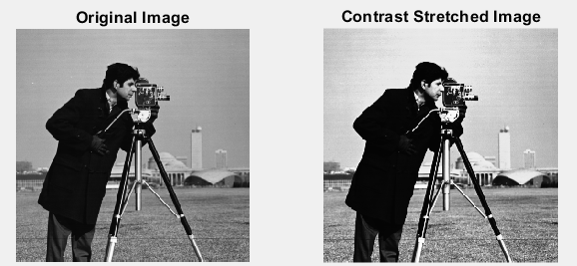

**Activity 2**

**Code:**

% Read the image

originalImage = imread('cameraman.tif');

% Convert to grayscale if RGB

if size(originalImage, 3) == 3

grayImage = rgb2gray(originalImage);

else

grayImage = originalImage;

end

% Convert to double for calculations

grayImageDouble = double(grayImage);

% Define slicing range (intensity values between 0–255)

low = 80;

high = 160;

% Method 1: Highlight range, keep background

slice1 = grayImage; % Copy of original

slice1(grayImage >= low & grayImage <= high) = 255;

% Method 2: Highlight range, suppress background

slice2 = zeros(size(grayImage));

slice2(grayImage >= low & grayImage <= high) = 255;

% Display results

figure;

subplot(1, 3, 1);

imshow(grayImage);

title('Original Image');

subplot(1, 3, 2);

imshow(slice1);

title('Gray-Level Slicing (with background)');

subplot(1, 3, 3);

imshow(slice2);

title('Gray-Level Slicing (without background)');

**Output:**

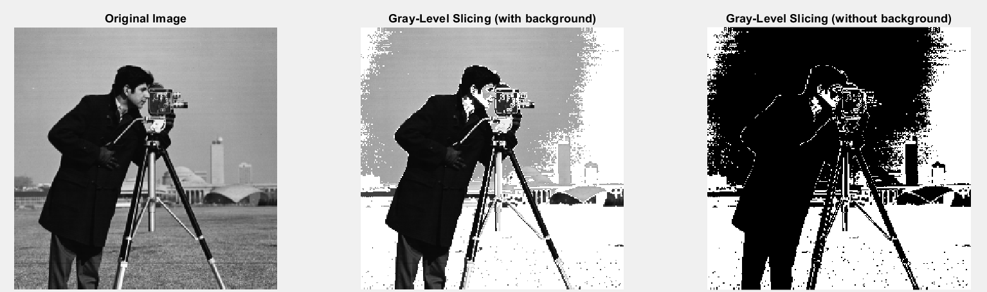

**Activity 3**

**Code:**

% Read the grayscale image

originalImage = imread('cameraman.tif');

% Convert to grayscale if RGB

if size(originalImage, 3) == 3

grayImage = rgb2gray(originalImage);

else

grayImage = originalImage;

end

% Display original image

figure;

subplot(3, 3, 1);

imshow(grayImage);

title('Original Image');

% Extract and display all 8 bit planes

for bit = 1:8

% Extract the bit plane

bitPlane = bitget(grayImage, bit); % bit = 1 is LSB, bit = 8 is MSB

% Display the bit plane

subplot(3, 3, bit + 1);

imshow(logical(bitPlane));

title(['Bit Plane ', num2str(bit - 1)]);

end

**Output:**

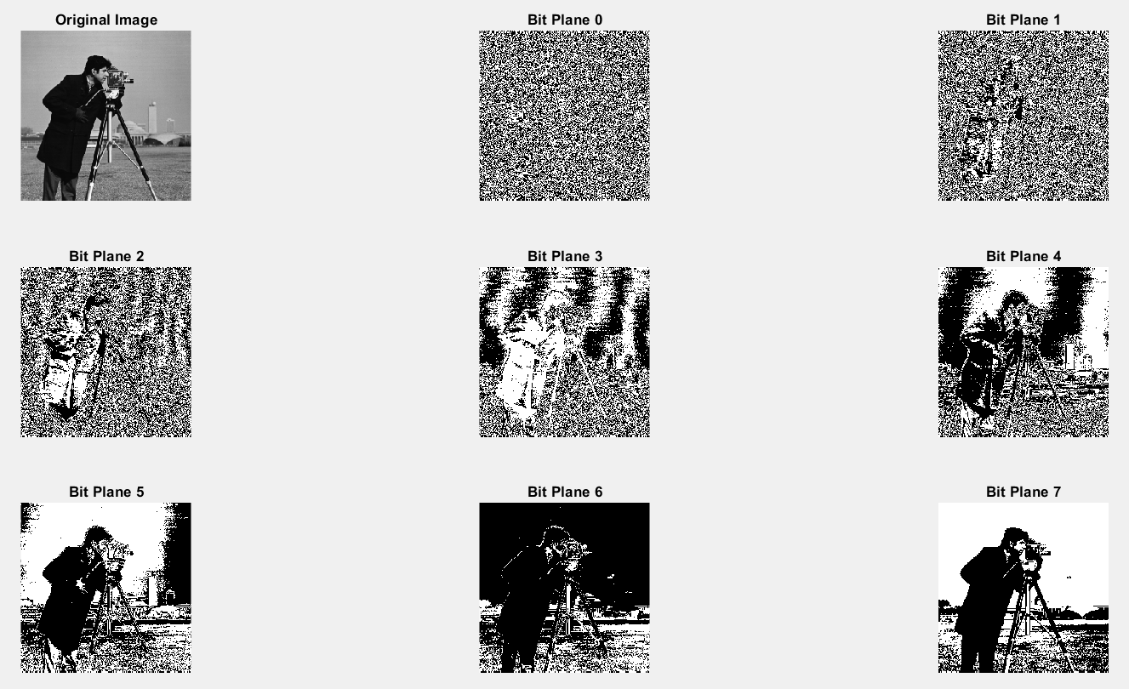

**Activity 4**

**(Part A)**

**Code:**

% Read an image (grayscale or convert it)

originalImage = imread('cameraman.tif');

% Convert to grayscale if RGB

if size(originalImage, 3) == 3

grayImage = rgb2gray(originalImage);

else

grayImage = originalImage;

end

% Display original image

figure;

subplot(2, 3, 1);

imshow(grayImage);

title('Original Image');

% ---- 1. Moving Average Filter (3x3) ----

averageKernel = fspecial('average', [3 3]);

avgFiltered = imfilter(grayImage, averageKernel, 'replicate');

subplot(2, 3, 2);

imshow(avgFiltered);

title('3×3 Moving Average Filter');

% ---- 2. Median Filter (3x3) ----

medianFiltered = medfilt2(grayImage, [3 3]);

subplot(2, 3, 3);

imshow(medianFiltered);

title('Median Filter (3×3)');

% ---- 3. Min Filter (3x3) ----

minFiltered = ordfilt2(grayImage, 1, true(3));

subplot(2, 3, 4);

imshow(minFiltered);

title('Min Filter (3×3)');

% ---- 4. Max Filter (3x3) ----

maxFiltered = ordfilt2(grayImage, 9, true(3));

subplot(2, 3, 5);

imshow(maxFiltered);

title('Max Filter (3×3)');

% Optional: Difference image (background enhancement)

backgroundEnhanced = imsubtract(maxFiltered, minFiltered);

subplot(2, 3, 6);

imshow(backgroundEnhanced, []);

title('Max - Min (Background Features)');

**Output:**

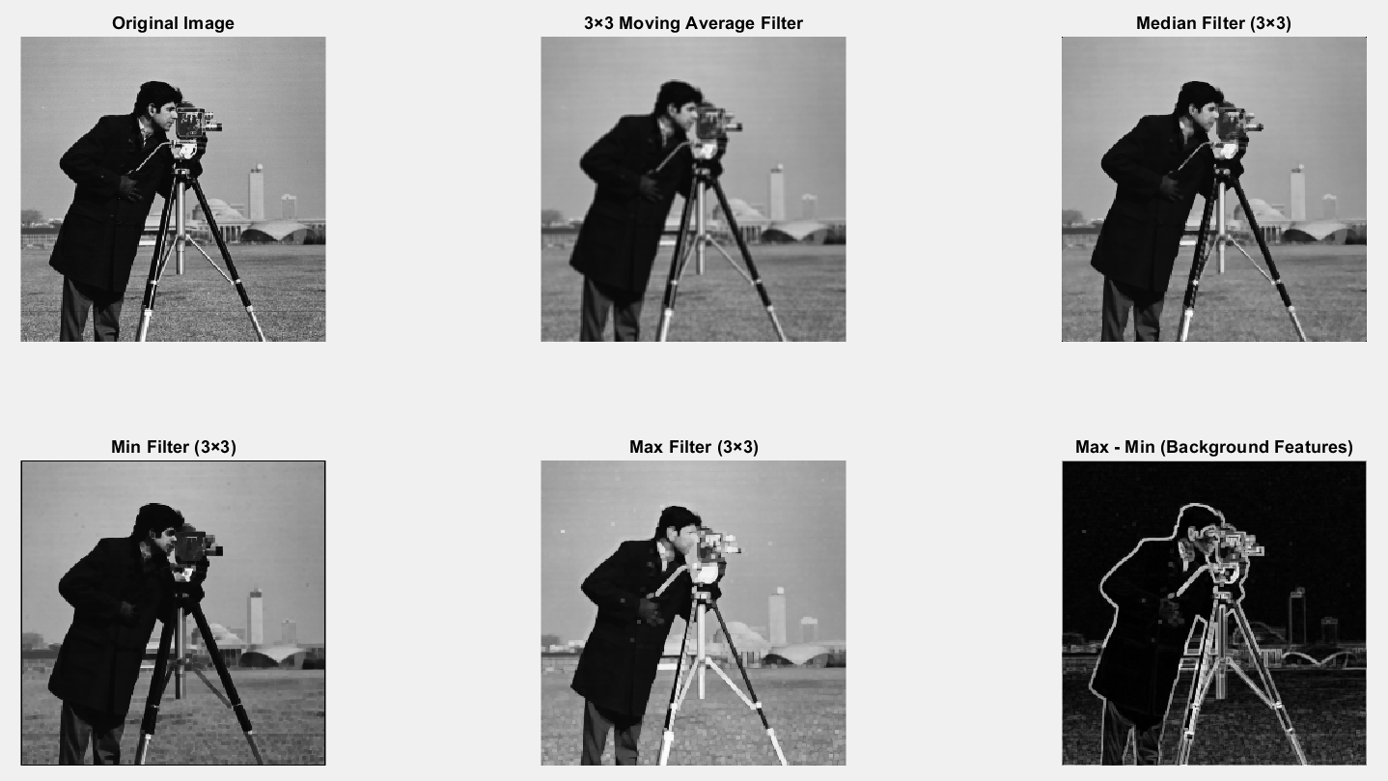

**(Part B)**

% Read the grayscale image

originalImage = imread('cameraman.tif');

% Convert to grayscale if it's RGB

if size(originalImage, 3) == 3

grayImage = rgb2gray(originalImage);

else

grayImage = originalImage;

end

% Apply Laplacian filter

laplacianKernel = fspecial('laplacian', 0.2); % Default alpha = 0.2

laplacianFiltered = imfilter(double(grayImage), laplacianKernel, 'replicate');

% Enhance image by adding Laplacian (sharpening)

sharpenedImage = double(grayImage) - laplacianFiltered;

% Normalize to display

sharpenedImage = uint8(mat2gray(sharpenedImage) * 255);

laplacianFiltered = mat2gray(laplacianFiltered);

% Display results

figure;

subplot(1, 3, 1);

imshow(grayImage);

title('Original Image');

subplot(1, 3, 2);

imshow(laplacianFiltered, []);

title('Laplacian Filtered (Edges)');

subplot(1, 3, 3);

imshow(sharpenedImage);

title('Sharpened Image');

**Output:**

